**ARUNODAY FOUNDATION**

**Juguldi, Uttarkashi**

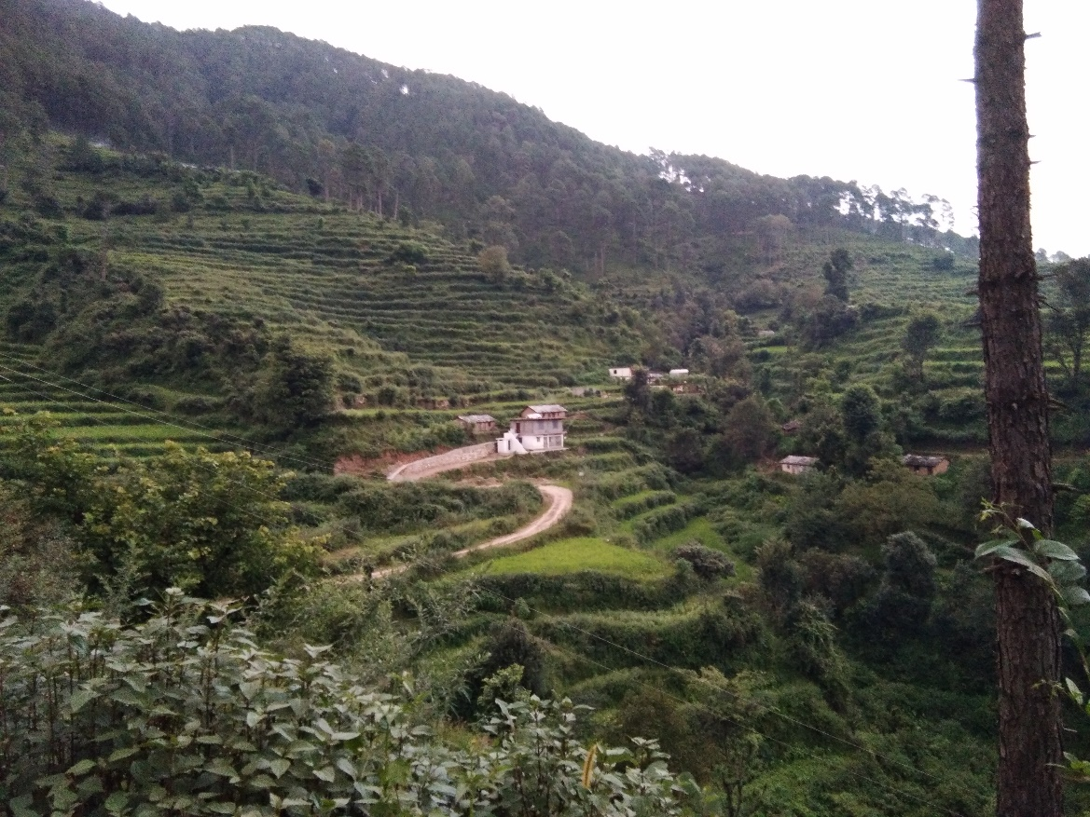

Arunoday Foundation School building in remote Juguldi village

**Earnest appeal for funds - expansion of elementary school for the underprivileged**

**Brief History:** Tapovani Mata Sant Subhadra mataji of Gangori Ashram, Uttarkashi, has been inspiring her followers to take up promotion of ‘**Shiksha, Swasthya and Sanskar**’ particularly in the remote villages of Uttarkashi which has been her ‘Karma Bhoomi’. Two of her followers, Gajendra Singh of Juguldi village, and Narendra Shetty of Mumbai, decided to put their resources together in this service to humanity & service to nation. They formed Arunoday Foundation on 25th of Feb 2016. The mission of the foundation is to provide quality **education and healthcare** to the rural children. A beginning was made taking a tough challenge. A pre-primary school was opened on 5th May 2016 at a remote mountain village called Juguldi in Uttarkashi, with no transport or other amenities, 5 km away from nearest paved road. The inauguration was done by Mrs. Jayendri Rana, President of Nagar Palika Parishad, Uttarkashi, in the presence of several supporters from outside and parents from the village. Several local dignitaries, including MLA, Mr. Gopal Singh Rawat, have extended their support and good wishes to this noble effort. In addition to providing quality education to the local children, Medical check-up of the school children and their parents is done at regular intervals. Healthcare and hygiene education is being provided to parents at every Parent-teacher meeting. India has a rich cultural heritage. Imparting these cultural values to children is part of our education process. The endeavor is to create a successful sustainable model and then replicate the model in other such remote villages.

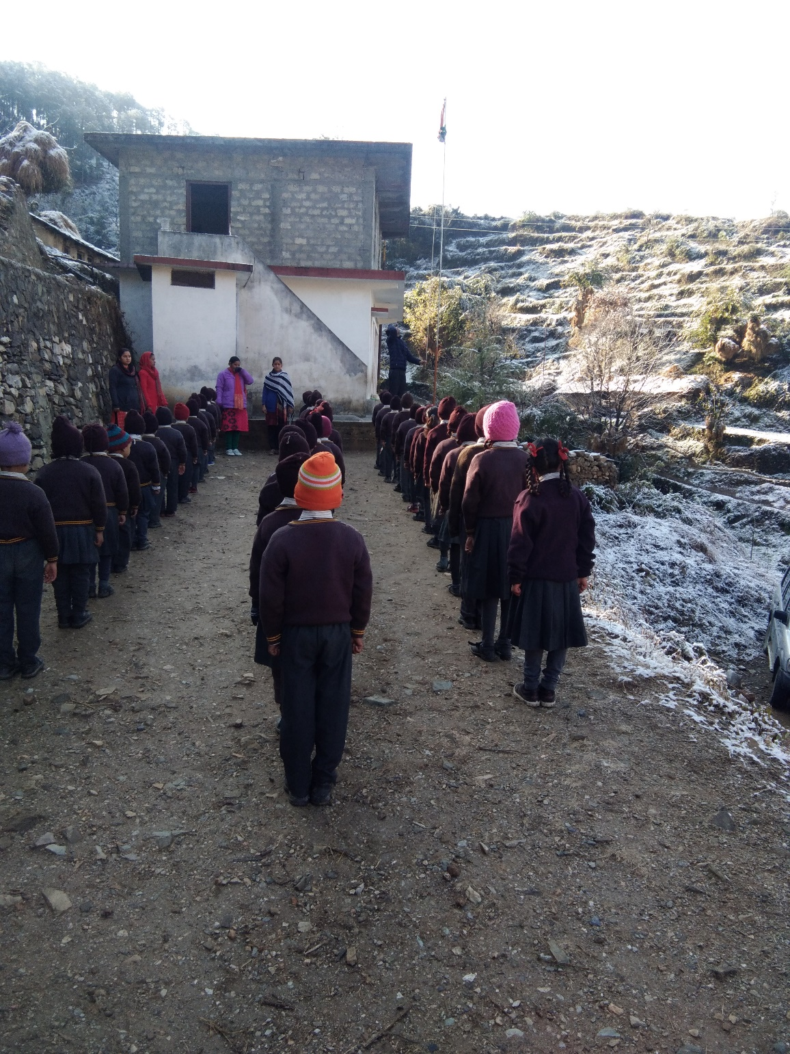

Flag hoisting at school on a snowy Republic day

**Present status:** The school has a building with 5 class rooms + office + toilets & sufficient playground on leased premise. Adding one additional class every year, now there are Nursery, Jr.KG, Sr.KG, 1st & 2nd std classes with 70 plus students and 5 teachers. The medium of Education is English as per parent’s wishes and with the intention of providing standard of education as good as any city school. A Software Engineer Mr. Dheeraj Kaushik of Delhi, has provided computers and computer aided education to the school. He has also developed a website for the Trust. A vehicle is provided to transport teachers to & from nearest township to the school as there is no regular public transport to the village. Our endeavor is to get well qualified and motivated teachers and provide the children with quality education which will put them on par with the city children. There is great desire among villagers to educate their children. This is leading to large scale migration of children to cities in search of education at enormous monetary and social costs and separation of children from their parents. The girl child unfortunately tends to get left out in this process. We are hoping to stop this by bringing quality education to villages. The school has received recognition from the Govt of Uttarakhand on 31st Oct 2019 for the next 3 years and up to 5th standard.

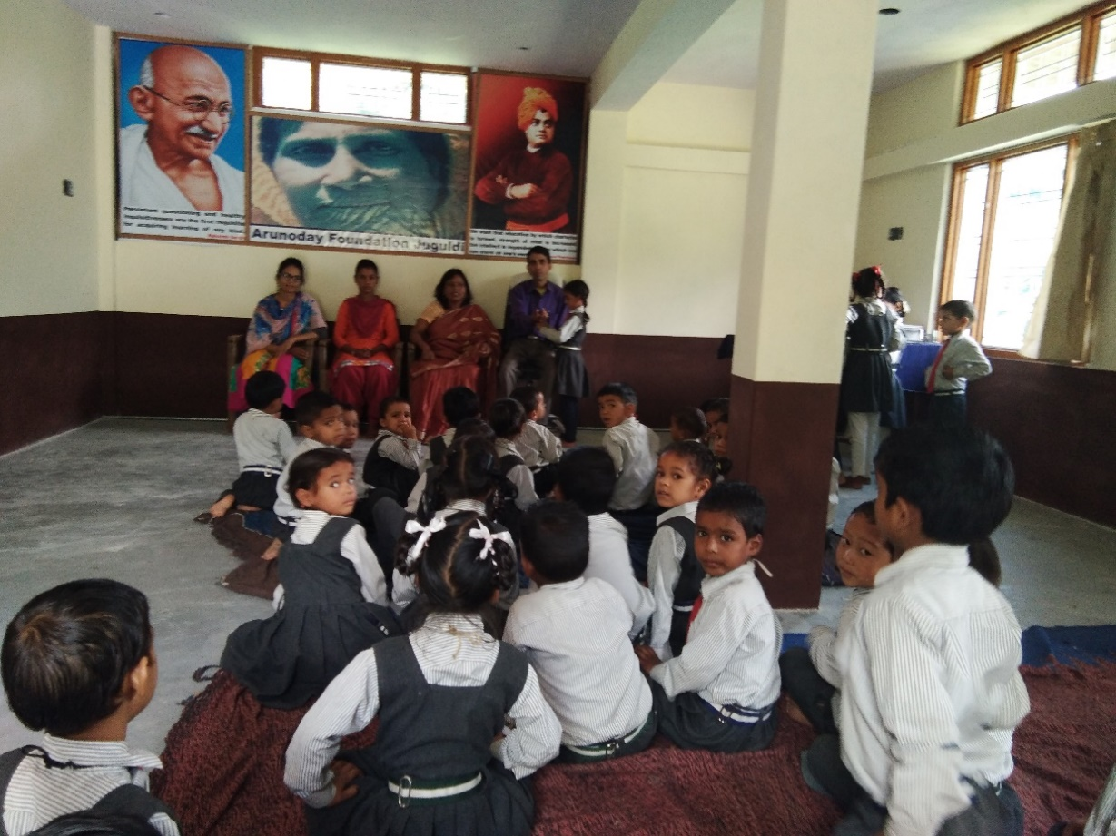

Class room activity

**Request for Funds for future growth:**

To add further classes the school needs additional building, classroom furniture and importantly more good teachers. Construction of a building of 3 floors with a total of eleven rooms is planned over a period of 3 years with an estimated cost of Rs. 40 Lac, to take care of the requirement of next 10 years. Hence we appeal to benevolent donors to contribute to this nation building cause. The Trust is now more than 3 years old and application has been made for Tax exemption for donors under 80G of Income Tax Act.

1. Individual donors are requested to donate any amount that they feel comfortable to contribute. What comes from the heart is our most prized gift and it will be used in various expenses of the school. A list of Donors will be displayed in the school.
2. Individual donors who wish to make larger contributions, corporate donors and CSR funds are requested to consider the following,
3. One classroom named after donor (in new building, larger classroom) – Rs. 3,00,000/-
4. One classroom named after donor (in present building – smaller classroom) – Rs. 2,00,000/-
5. One large classroom furniture – 1,50,000/-
6. One small classroom furniture – 1,00,000/-
7. One teacher sponsored for a year – 1,00,000/-
8. The school can also accept following donations:
9. Used or new computers/Laptops in working condition.
10. Used or new teaching aids, children’s books, stationary, sports goods, toys.
11. Used furniture of any kind usable at school, provided they can be reached to the school.
12. Good teacher willing to work in remote villages is extremely hard to find. We welcome educated volunteers who are willing to spend some time with our children at a time of their convenience. We could provide a decent living space and transport. For nature loving city dwellers we provide an excellent escape, absolutely quiet, clean & peaceful environment. The place is close to heaven for the spiritually oriented. Once we have high speed internet available (4G) we intend to enroll volunteers from cities to teach our children through video link.
13. Individuals and NGOs involved in similar type of activity are welcome to share their experience and provide us with any kind of support.

Bank details of Arunoday Foundation:

Acc Name: **Arunoday Foundation**

Acc No.: **76013119882**

Bank Name: **Uttaranchal Gramin Bank**

Branch: **Matli, Uttarkashi**

IFSC Code: **SBIN0RRUTGB**

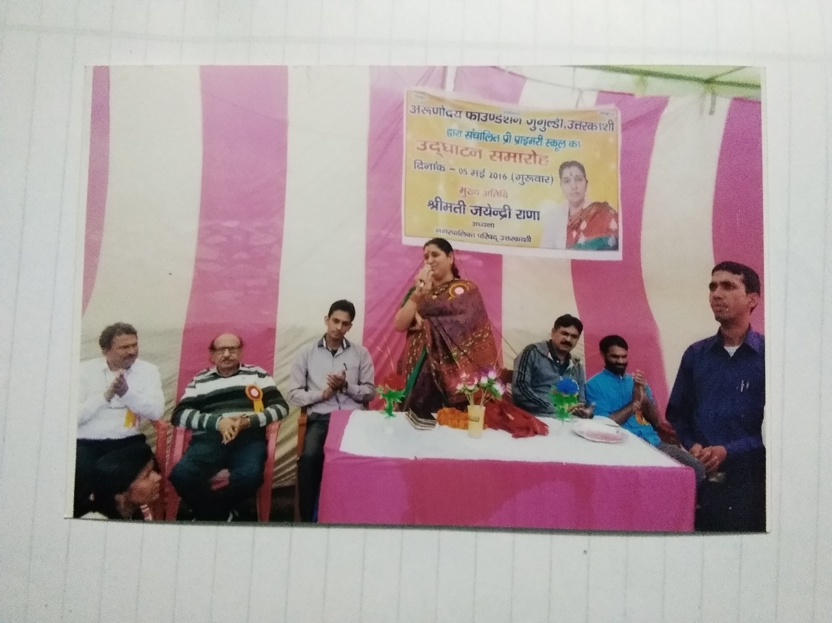

Inauguration of school by Mrs. Jayendri Rana, President, Uttarkashi Nagar Palika Parishad

CONTACT

Secretary: **Gajendra Singh – 9997180800** Founder: **Narendra Shetty – 9920075306**

**Email:** [**arunodayf@gmail.com**](mailto:arunodayf@gmail.com) **Web: WWW.arunodayfoundation.com**

**NEW SCHOOL BUILDING PLAN**







